**A**

**MINOR PROJECT**

**On**

**[ FARMER WELLNESS PROJECT ]**

**Classification Different Classes of Seeds**



**Government Engineering College**

**Raipur**

**Submitted By:**

**Mahendra Kumar Pankaj**

Roll no. 301602217032

Enrollment no. BD4780

**DECLARATION**

I Mahendra Kumar Pankaj student of VII th semester in 4th year, department Computer Science Engineering, declare that I have actively undergone 30 days training at Ancient Labs Private Limited Institute from 20th august 2020 to 20h september 2020 and all the information provided in this report is true to the best of my knowledge and will bear all responsibilities of possible discrepancies.

…………………..

**Mahendra Kumar Pankaj**

Student’s Signature & Name

**ACKNOWLEDGEMENT**

We express our gratitude to **Dr. R. S. Parihar,** Principal of **Government Engineering College, Raipur,** for his valuable suggestions and advices throughout the Bachelor of Engineering course. We would extend our gratitude to our HOD **Dr. R.H. Talvekar.** We also express our sincere thanks to **Mrs. Poonam urkure,** mentor at **Computer Science Department of Govt. Engineering College, Raipur** for his guidance throughout our project completion. We also extend our thanks to faculties of college for their cooperation during our course .We are also thankful to Department of Computer Science & Engineering, Govt. Engineering College Raipur, for all the facilities for successful completion of vocational training. We are thankful to college for this golden opportunity to provide this time period to do training as it helped us to learn a lot to implement our work with this project.

Submitted by:

**Mahendra Kumar Pankaj**

Roll No. : 301602217032

...............................................

Signature and Date

**TABLE OF CONTENT**

Abstract ..........................................................................................................i

Chapter1**.** Introduction...................................................................................ii

1.1. Overview of the Institute.....................................................

1.2. Actual work..........................................................................

Chapter **2**. Objectives...................................................................................... iv

Chapter 3.Observations...................................................................................v

Chapter 4.Working principle......................................................................... vi

4.1. Data loading…………………………………………………

4.2. Training the Model…………………………………………

4.3. Prediction…………………………………………………...

Chapter 5.Methodology..................................................................................ix

5.1. Hardware Requirements......................................................

5.2. Software Requirements........................................................

Chapter 6.Conclusion..................................................................................xii

**ABSTRACT**

Seed classification is a process in which different varieties of seeds are categorized into different classes on the basis of their morphological features. In the present work we performed seed classification using Weka tool. The data was collected from UCI website’s database. The features of seed used are area, perimeter, Compactness, Length of kernel, Width of kernel, Asymmetry coefficient and length of kernel groove.

In this classification we used Functions are Numpy, Pandas, Keras, Tensorflow, sklearn, Dence, sequential and activation function. We trained the model by using basic training set method (Neural Network) with **“RELU”** activation function for input and hidden layers and we use **“SOFTMAX”** activation function for output layer, then after we compile the neural network by **“Categorical_Crossentropy”** method. Finally we observed that Training Set method gives accuracy of **92.38%** during the classification process.

**[i]**

**CHAPTER 1**

**INTRODUCTION**

**1.1 Overview of the Institute:**

It is a training institute which provides various vocational training in different programming languages such as Deep Learning, Machine Learning, Python, HTML, CSS, Java, Java Script, PHP, and many more. It has a team of technical people.

The lead trainer has a working experience of more than 3yrs in Deep Learning.

**1.2** **Actual Work:**

The ANN modeling becoming very popular in different areas of agriculture, specially, in the areas where straight statistical modeling becomes unsuccessful. The ANN is using in the field of agriculture to predict the crop yield, biomass production, seeding dates, physical and physiological damaging of seeds, organic matter contents in the soils, soil moisture estimation, aerodynamic properties of crops, estimation of sugar content in fruits and characterization of crop varieties.

In this paper shows the capability and potential of machine learning with the well-trained multilayer neural network classifiers for shapes, sizes, and varietal type identification of irregular wheat samples grown in the assorted agro environmental zones in the country.

Classification and seed analysis can deliver additional information and knowledge in their production, seeds quality control and its contaminations identification. Normally these tasks and activities are accomplished by specialists by visually reviewing each sample, which is a very wearisome and time consuming activity. Computer Vision technology is applied for the inspection of quality of wheat seed for achieving the accurate and fast inspection performance. To attain the identical quality standard from various inspection staffs those have various levels of experience and skill is a hard hitting task.

**[ii]**

To attain the identical quality standard from various inspection staffs those have various levels of experience and skill is a hard hitting task. This method is suggested for the classification of the quality of wheat seeds according to their defects types.

A comparison of a supervised (Back Propagation) and an un-supervised (Self Organizing Map) artificial neural network is made to classify the wheat seed varieties in this paper. This research is concluded as the unsupervised artificial neural network gives better performance with 91% accuracy as compared to the supervised artificial neural networks which gives 84% accuracy. The classification of wheat seeds varieties was made according to the morphological properties of wheat seeds, by considering its 210 samples which includes its three varieties: Kama, Rosa and Canadian.

This model helps to classify the seeds according to several aspects of their quality and

other properties they showcase which can occur like a problem to their business and can

leads them towards a big loss or misconcious business. So to avoid this problem we have

worked on this model.

**[iii]**

**CHAPTER 2**

**OBJECTIVE**

India is a farming leading country and hence secure a quite good position in the world for that.

As of now there are several farming based ventures that make it an active market for rising entrepreneurs to make a place for them in this market. This model can affect the market as of now this model is not applied in every ventures present in the country.

The main objective of application of this model is to help in the mass distribution or other commercial ventures to provide them a classification of seeds about what they are using to do

the work.

This model helps to classify the seeds according to several aspects of their quality and

Other properties they showcase which can occur like a problem to their business and can leads them towards a big loss or misconcious business. So to avoid this problem we have worked on this model.

**[iv]**

**CHAPTER 3**

**OBSERVATION**

Now a days farmers are facing a problems that they are not getting that much according to what they are doing like hard work and dedication, But not getting the results according to their efforts. Keeping this in mind the model can be used as an helper to them as what kind of farming can help them in their growth, and for that this model can help in getting the good quality of seeds for getting better crops.

As of now in indian farmer grows a “mahamaya rice” breed with all his dedication and not getting that much of result for their hard work, but instead of that if they use “Basmati rice” for farming they can earn more from their earlier earnings. All they have to do is just testing and using the good quality of seed for further operations.

From this model we are predicting the class and quality of the provided seed batch and can approve/decline for their further uses in real life situations, and to set a benchmark for any operation of distribution of seeds to the farming lands.

**[v]**

**CHAPTER 4**

**WORKING PRINCIPLE**

* At first we have trained our model with provided dataset.
* After training the neural network with dataset we test the model with sample dataset to check if it’s providing us with our desired output.
* Then we calculate accuracy of the model through expected output and predicted output.

**4.1. Data loading**

For loading the seeds dataset we use Pandas library which is used in python for data analysis.

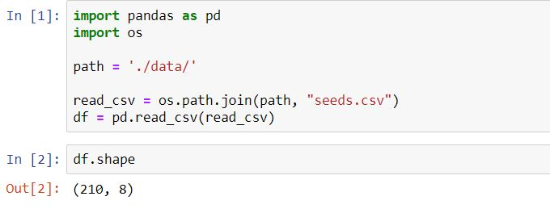

**[vi]**

**4.2. Training The Model**

Here we train the model with required epochs which is intended to train the model for its prediction by performing the task again and again.

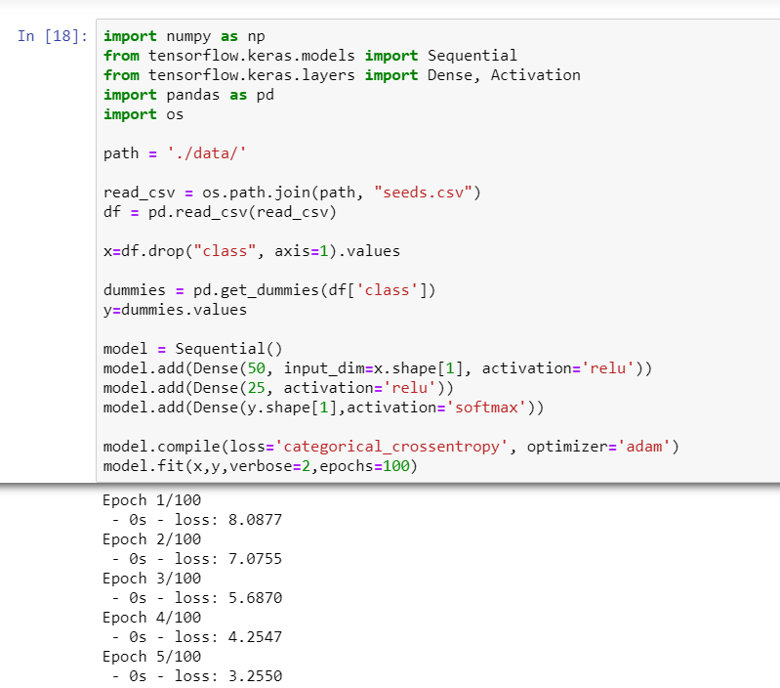

**[vii]**

**4.3. Prediction**

Here we provide our model with a set of various seed properties to make it predict the class of the seed.

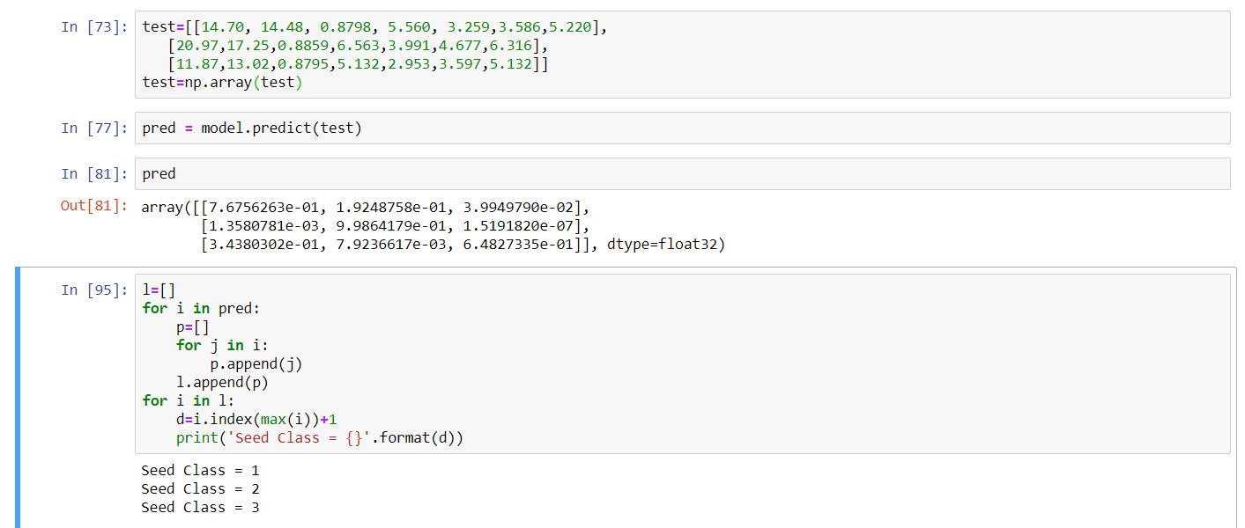

**[viii]**

# ****CHAPTER 5****

**METHODOLOGY**

# **While making this model I went through various software and hardware platform. As our project is an Deep Learning based project therefore knowledge of**

**4.1.Python:**

**Python** is a general purpose and high level **programming** language. You can **use Python** for developing desktop GUI **applications**, websites and web **applications**. Also, **Python**, as a high level **programming** language, allows you to focus on core functionality of the **application** by taking care of common **programming** tasks**.**

**4.2.Tensorflow :**

TensorFlow is a free and open-source software library for dataflow and differentiable programming across a range of tasks. It is a symbolic math library, and is also used for machine learning applications such as neural networks.

**4.3.Numpy & Pandas**

**Numpy** is a library for the Python programming language, adding support for large, multi-dimensional arrays and matrices, along with a large collection of high-level mathematical functions to operate on these arrays.

**[ix]**

**Pandas** is a software library written for the Python programming language for data manipulation and analysis. In particular, it offers data structures and operations for manipulating numerical tables and time series.

### 

### ****4.3.**** Software Requirements

### 4.3.1. **JuPyter NoteBook**

### The Jupyter Notebook is an incredibly powerful tool for interactively developing and presenting data science projects. A notebook integrates code and its output into a single document that combines visualisations, narrative text, mathematical equations, and other rich media.

Below are some common Libraries used in Jupyter Notebook:

* Scipy
* numpy
* sklearn
* pandas
* pandas-datareader
* matplotlib
* requests

### 4.3.2. Jupyter Notebook - Benefits and Advantages

* **All in one place**: The jupyter Notebook is a web-based interactive environment that combines code, rich text, images, videos, animations, mathematical equations, plots, maps, interactive figures and widgets, and graphical user interfaces, into a single document.
* **Easy to share**: Notebooks are saved as structured text files (JSON format), which makes them easily shareable.
* **Easy to convert**
* **Easy to customize**
* **Easy to create kernel wrappers**
* **Interactive code and data exploration**

**[x]**

**4.4 Hardware Requirements**

**4.4.1. Personal Computer:**

* OS version Windows 10 (32- or 64-bit)
* Intel pentium 4 or AMD RADEON 64 ptocessor ( 2 Ghz or faster )
* 2 GB of ram Minimum ( 8 GB recommended)
* 1280 x 800 minimum screen resolution
* **Graphics card (Minimum 2GB)**
* **Internet connection for environment setup**

**4.4.3. Pen drive:**

**Minimum 2GB to transfer software files**

**[xi]**

**CHAPTER 6**

**CONCLUSION**

At last I come to the conclusion that the model I made is very useful keeping in mind the growth in the Farming and urge of farmers to increase their earning with time.

This model is accurate for about 92.38% which can predict the seed class which it got by training the model with the same dataset that we have used to train it before.

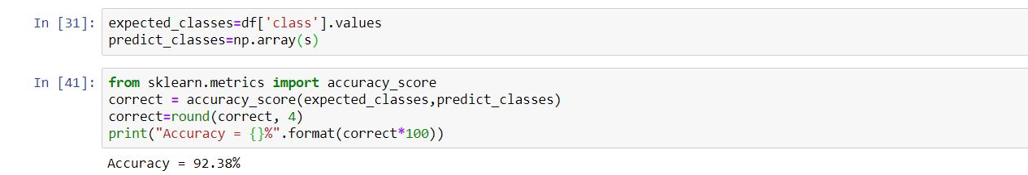

With this accuracy we can expect the maximum accurate prediction of the seed class and can often classify it in batches.

**[xii]**

